2021

Big Data Architecture & Governance



**Student Names:**

Navaneeta Naik

Nikunj Doshi

Yu Ren

**Assignment Name:**

Group Assignment

Contents

2. Assignment 2

2.1. Case 2

2.2. Assignment Goals 2

2.2.1. Visualization Deliverables 3

2.2.2. Other deliverables 3

3. Documentation 4

3.1. Vision Diagram 4

3.2. Data Wrangling and Cleansing 5

3.3. Database Installation 6

3.4. Data Mapping and Integration 7

3.5. Data Validation and Data Visualization 8

3.6. System Integration and User Acceptance Testing 9

3.7. Challenges Encountered 10

3.8. End User Instructions 11

# Assignment

## Case

Each team should select a dataset to analyze and build an analytical dashboard as a Proof-of-concept to illustrate the value of data driven analytics. You need to present your dataset.

.

## Assignment Goals

To work with datasets, Perform/Create:

* Group Assignment/Project on Velero with below mentioned activities:
  + Tasks/ Project Short/ Long Form/ Group Allocation/ Timesheet/ Issues & Risks.
* Data Profiling – Using Python profiling library, describe your understanding of the data.
* Data Wrangling and Cleansing - Pandas/Alteryx/XSV
  + Filtering and Aggregating if needed.
  + Missing value handling.
  + Deriving additional columns from existing datasets if needed.
  + Cleaning (removing blank spaces, formatting dates, Capitalizing etc.) .
* Database Installation: Install NEO4J database .
* Data Mapping and Integration to your Database for the Entire Dataset.
* Business and Technical Metadata – develop business term list describing all the data elements available in the file.
* Data Validation and Data Visualization using Python – Validate the data using python and provide a dashboard using python visualization libraries.
* System Integration and User Acceptance Testing - Test Cases – describe your validation & testing process.
* Risks/Issues of project.
* Describe challenges encountered and how you resolved them.
* End User Instructions (Steps to run your Dashboard) – provide a full description how to run your process:
  + Database Creation and load.
  + Visualization interpretation - describe information regarding your findings.

### Visualization Deliverables

Once you wrangle/clean/join/integrate the data, import the data into **NEO4J** and illustrate how to use the appropriate graph to illustrate various aspects of analysis.

Questions to consider:

* Columns used for dimensions, and columns that are used for measurement.
* How would you generate new dimensions?
* Who would use this dashboard and how they benefit from your dashboard?
* What value would be generated using this dashboard?

### Other deliverables

* Presentation of the entire work from the first step till the dashboards including the Velero screenshots.
* Business and technical metadata presentation – Identifying all available business terms and extracting related technical metadata.
* Complete explanation of the dashboard and usability.
* Complete instruction as how to implement and run the database load, technical meta data extraction, and dashboard.

# Documentation

## Vision Diagram

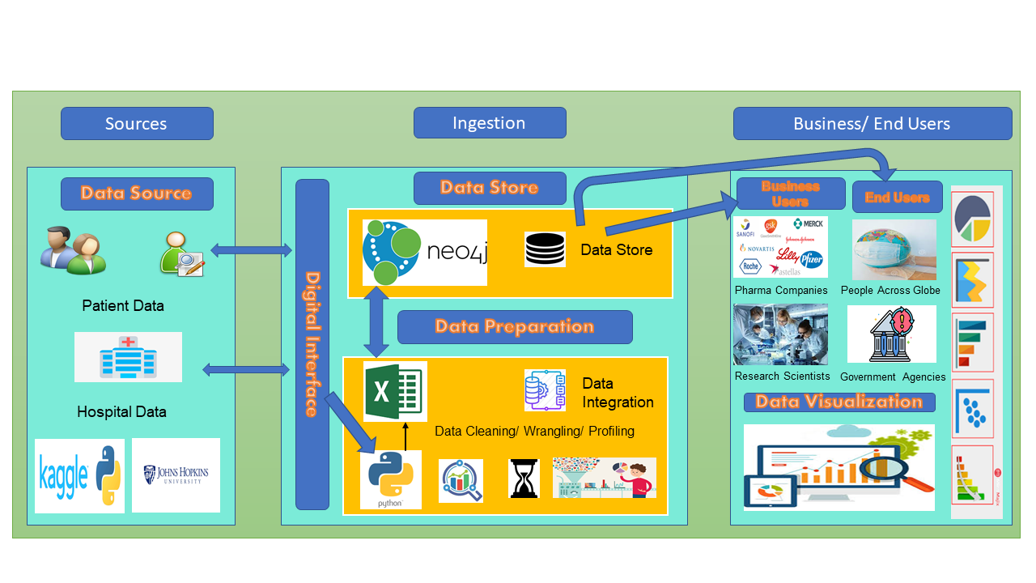

Data is being collected from data sources such as Patients and Hospitals and those have been compiled in the dataset on Kaggle through John Hopkins University

Before the data is being sent to the Data Store in Neo4j, it needs to clean, wrangled and profiled extensively which has been done using Python and Pandas Profiling Library.

Then, Data Modelling and Data Integration is done on the Neo4j database.

Visualizations we get after analyzing the data will be used by the Business Users such as Pharma Companies and the Research Scientists as well as End Users such as Government agencies and the people across the globe to track covid cases and implementation measures.

## Data Wrangling and Cleansing

* Data Wrangling & cleaning is done to make use of the raw data for analytics
* Data Wrangling & Cleansing processes were performed using Pandas

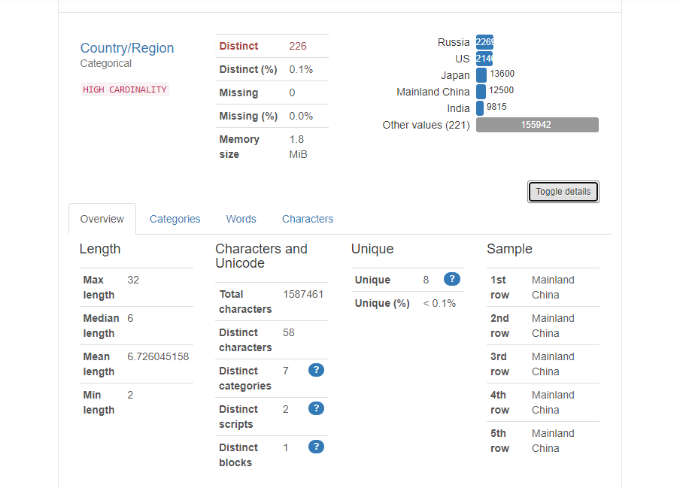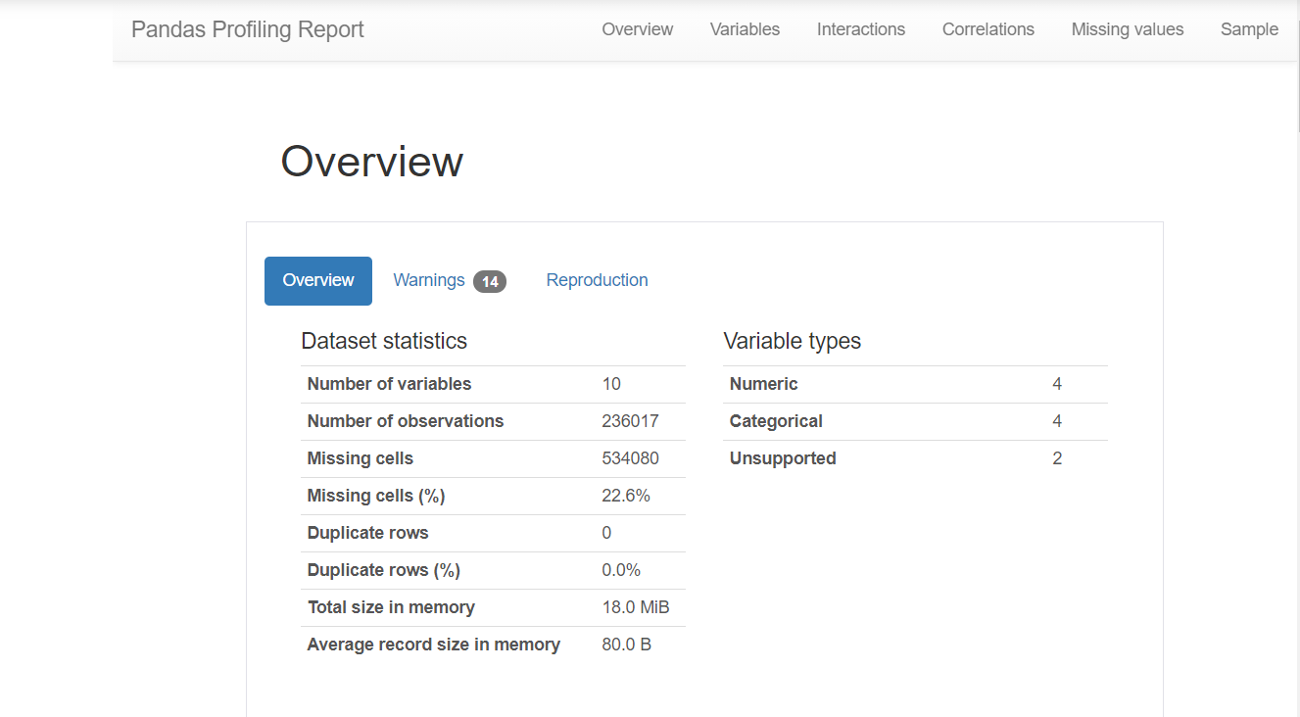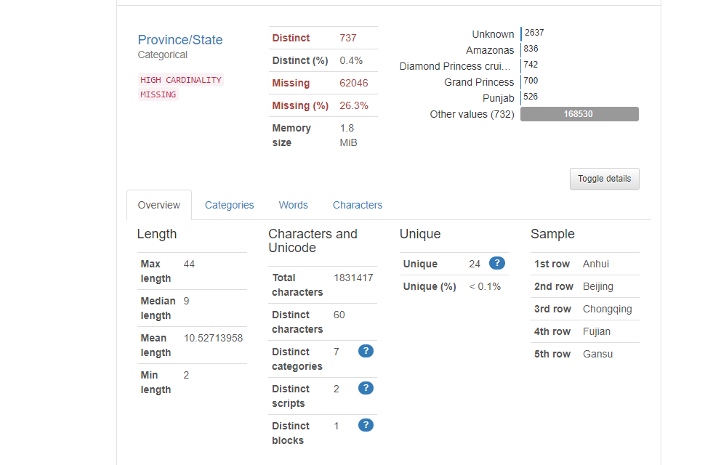

* Performing data profiling on our dataset gave us an insight on the missing values in our data and other details in our dataset which helped us understand our data

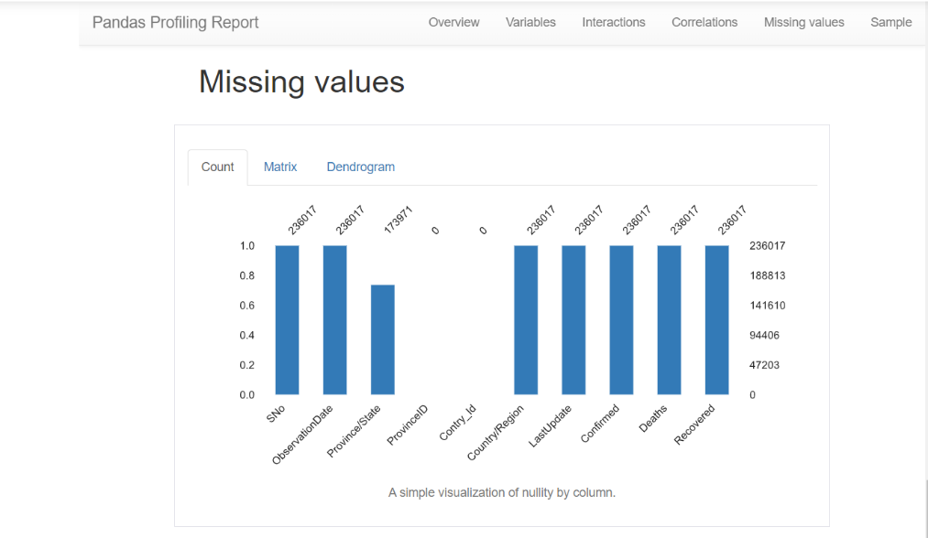

* Handling Missing Values:

1. All the missing values in Province/State column were replaced with “not available”.
2. All other columns did not have any missing values

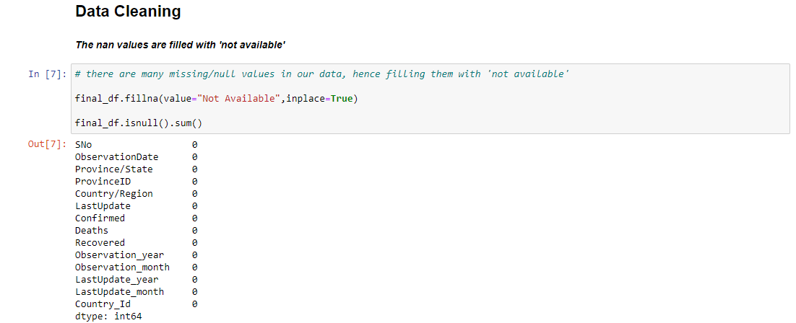

* New columns were generated using the existing columns.

1. Date of Observation was used to derive year of observation and Month of observation columns
2. Country & Province columns were used to derive unique id numbers country id and province id which would then identify unique countries or states
3. Last Update column was used to derive the last updated month and last updated year columns

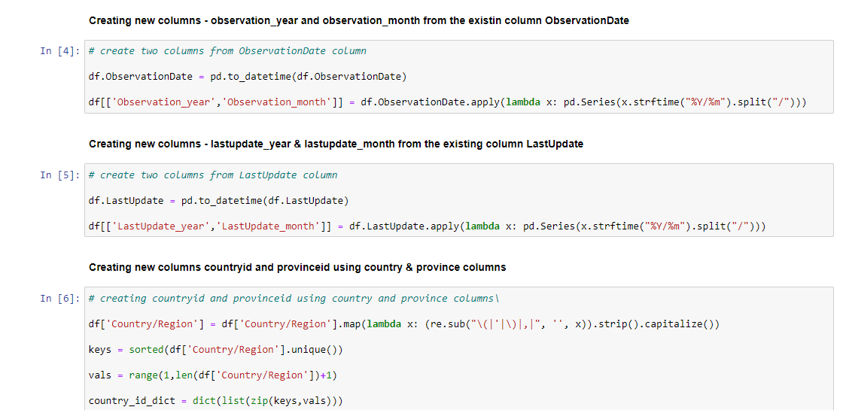

## Database Installation

* Install Neo4j Desktop
* Create Database:

1. Create a new project named “CSYE7250Final”.
2. Add a new local DBMS named “COVID19”. The default username is ‘neo4j’. Set the password ‘123456’.

* Import Data Source:

1. Open the folder and enter import directory.
2. Paste the CSV file to this directory and change it name ‘COVID19.csv’.

* Install APOC in plugins of the database for exporting the metadata.
* Start the database
* Database Information:

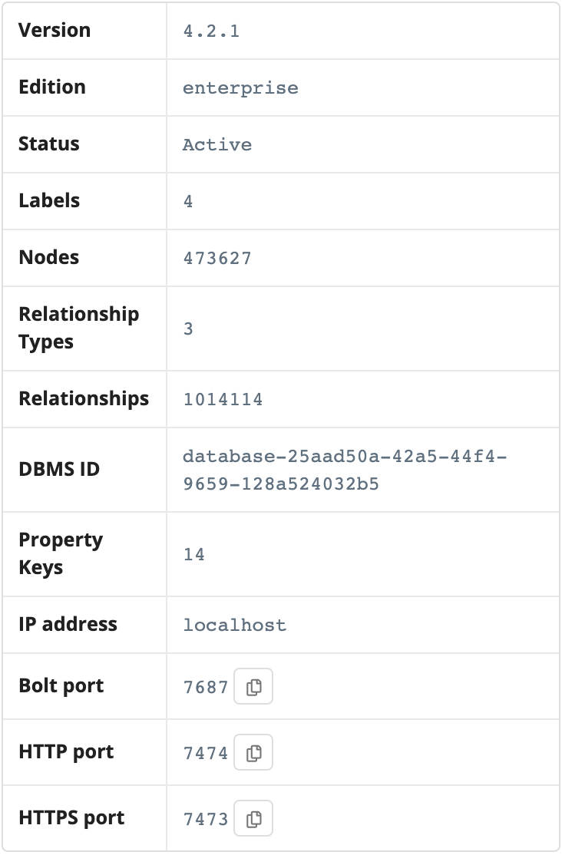

## Data Mapping and Integration

* Open Neo4j Browser. It will connect with the database automatically.
* Create Constrains:

1. country node: CountryId is unique
2. province node: ProvinceId is unique
3. date node: ObservationDate is unique
4. infectionStatus node: EntryId is unique

* Create Nodes and map data columns to the Node properties one by one

* Establish the relationships according to the following draft:

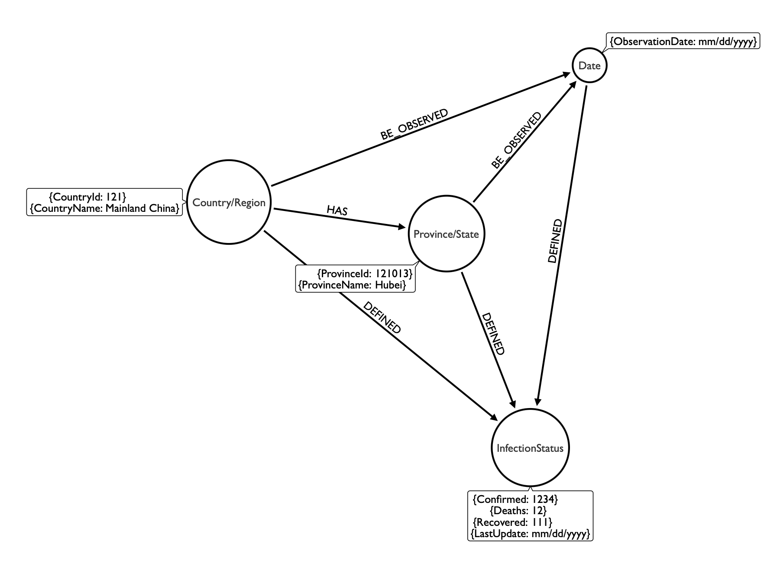

* Get the Nodes Information:

* Get the Relationships Information:

## Data Validation and Data Visualization

* Data Visualization is the graphic representation of data that helps understand the data without requiring technical knowledge
* Data validation & Data visualization were performed using Python
* These visualizations could answer questions like
* What was the difference between the confirmed, recovered and death numbers for different month & year?

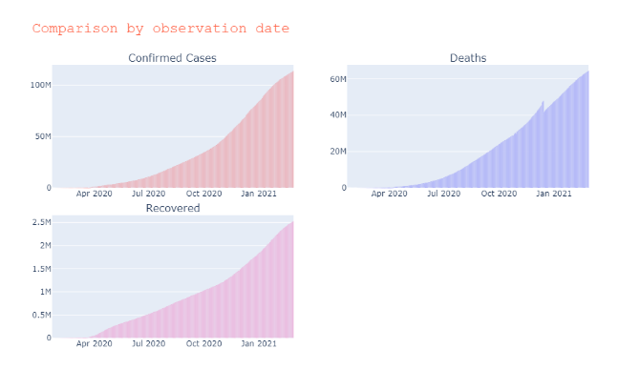

* What was the country that had highest number of deaths?

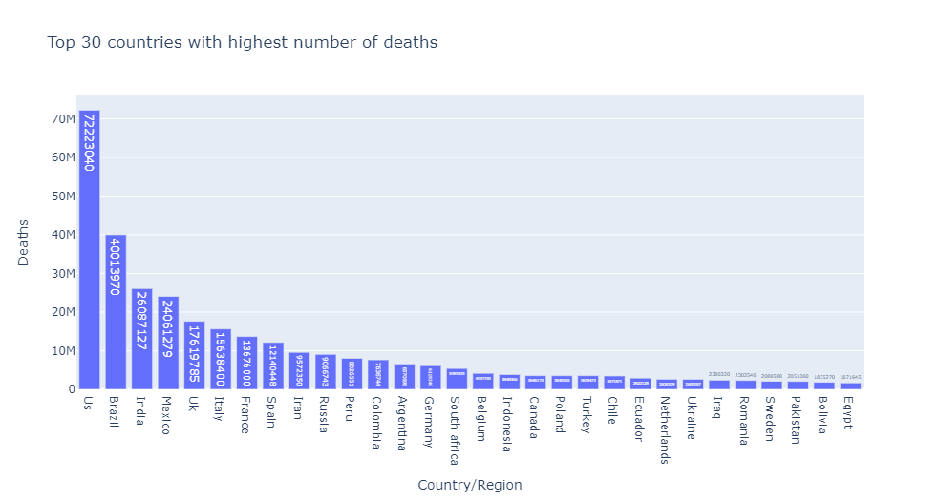

* What was the country that had highest number of recovered patients?

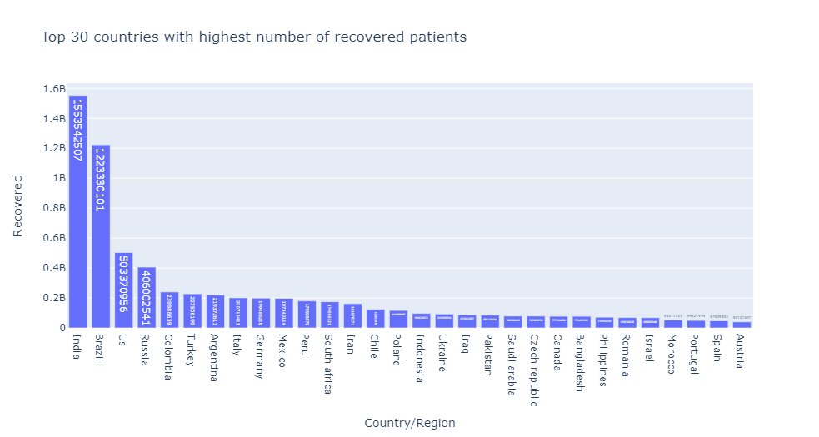

* What was the country that had highest number of confirmed cases?

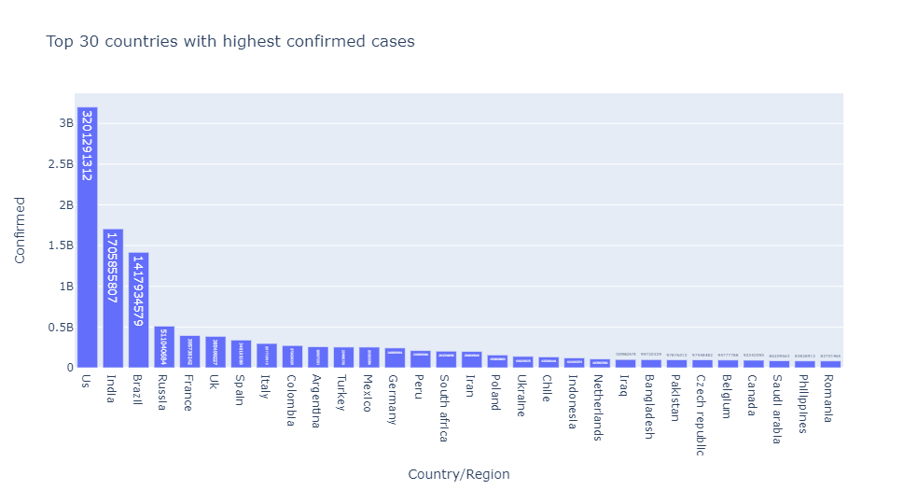

* Which State had highest number of deaths?

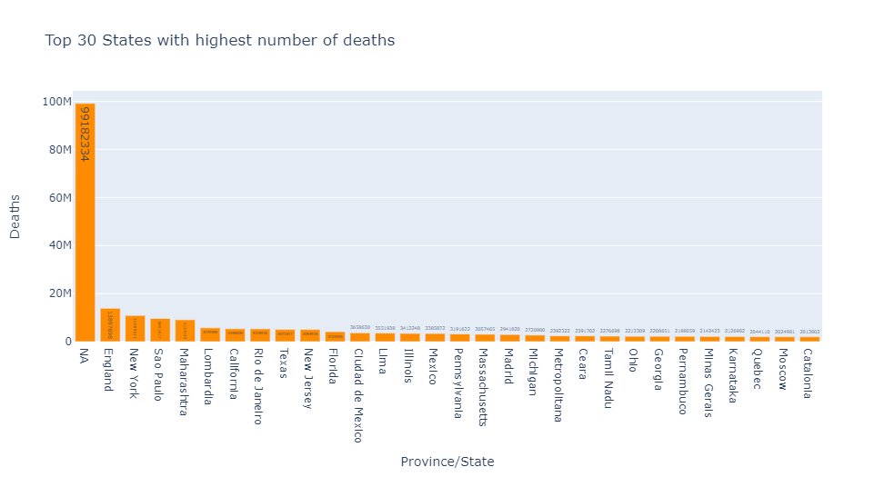

* What was the difference between the confirmed, recovered and death numbers for different countries?

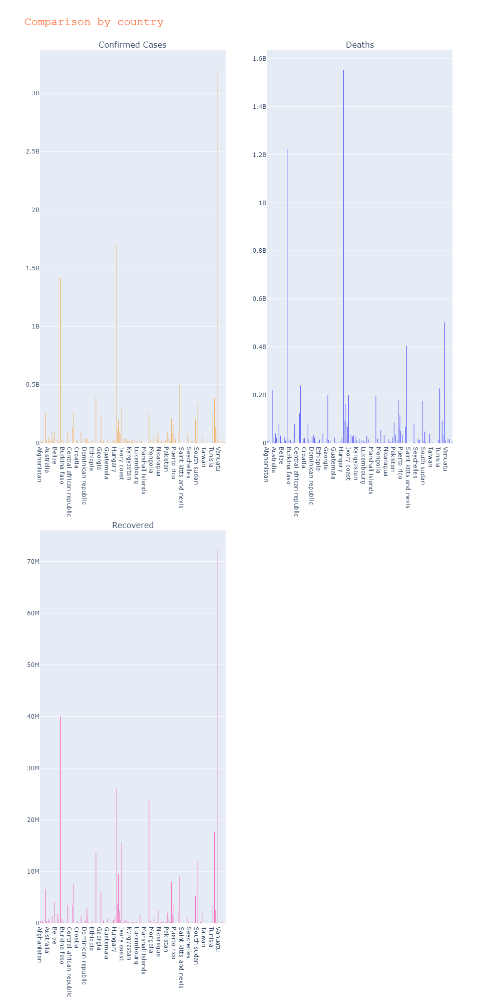

* What was the difference in number of deaths in year 2020 and year 2021?

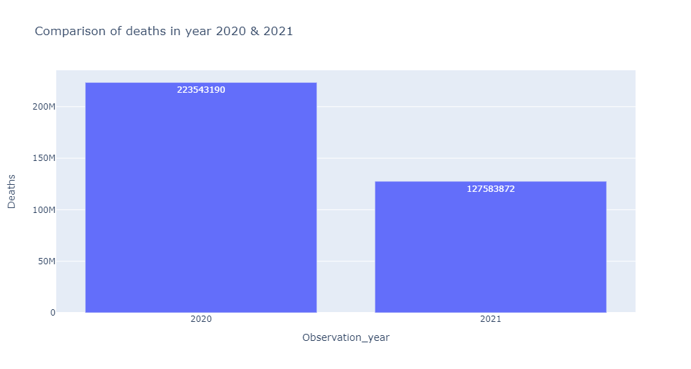

* What was the difference in number of patients that recovered from covid in the year 2020 and year 2021?

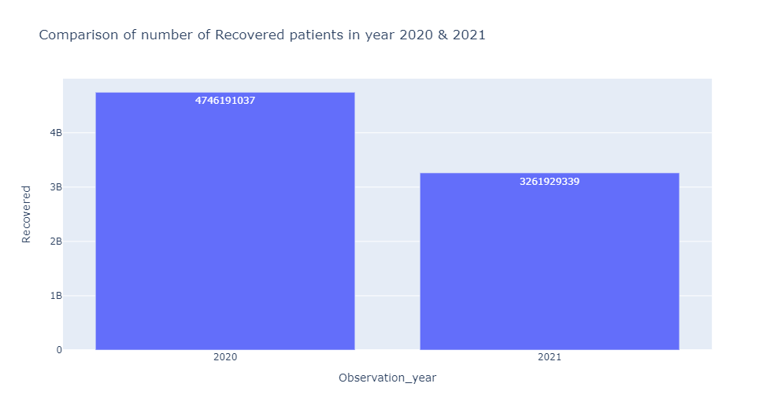

## System Integration and User Acceptance Testing

**System Integration Test Cases**



**UAT Test Cases**



## Challenges Encountered

1. Python:

* Null Values: The dataset had around 62000 missing values to be handled. Since dropping the columns would reduce the dataset and have an impact on the visualizations, we decided to fill the null values with “not available” so that even this data could be used for our further analysis
* Generating ProvinceID: A new column ProvinceID was created to better help in viewing data by grouping them as different provinces. It was a challenging execution, but with references from python documents we were able to do it

1. NEO4J:

* Forget Password and Reset Error: When we want to connect with the database, we forgot the password and we try to reset the password but it fails. Finally we create a new one so that we can use.
* Exporting Metadata Error: There are some NaN values when we want to export our metadata which make things wrong. We filter the error value in the loop of processing the data.

## End User Instructions

**Python:**

1. Install python libraries: pandas, pandas-profiling, matplotlib, seaborn.
2. Download the dataset: [Novel Corona Virus 2019 Dataset | Kaggle](https://www.kaggle.com/sudalairajkumar/novel-corona-virus-2019-dataset?select=covid_19_data.csv)
3. Run the csye7250_project. ipynb in Jupyter Lab or Jupyter Notebook
4. Visualizations can be used to compare and understand how different countries have been affected by COVID-19